第四节：结尾段写作
通过本节课，你将会
- 掌握开头段和结尾段写作句型
- 掌握全文篇章写作
- 重点词汇运用

开头段写作句型
开头段格式：改写题干 + 提出观点
- 原则 - 1. 体现语言能力；2. 让考官明白你看懂题目 - 只改核心内容
- 结构 - 改写题干 + 任务回应句
- 改写方法
句型语法 - 如：主动变被动；although - ...... however,......；语序
换词性 - 如：improve sth - make improvement in sth
词汇替换 - 如：focus on - concentrate on；ban - prohibit
表达替换：benefit sth - have positive effects on sth
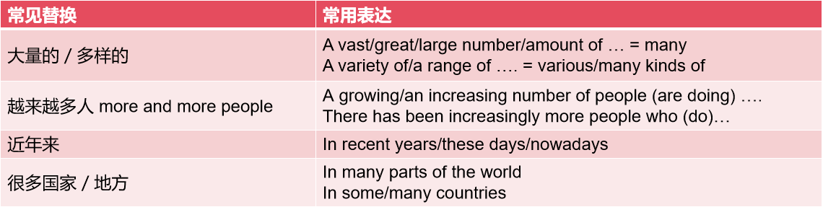

Positive or negative

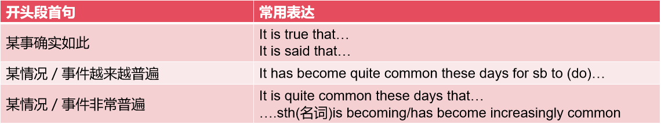

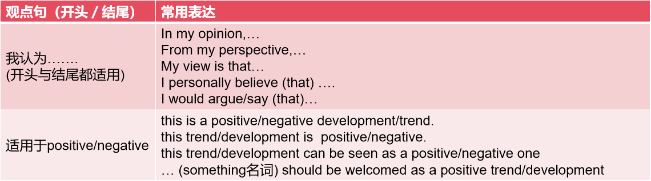

Outweigh

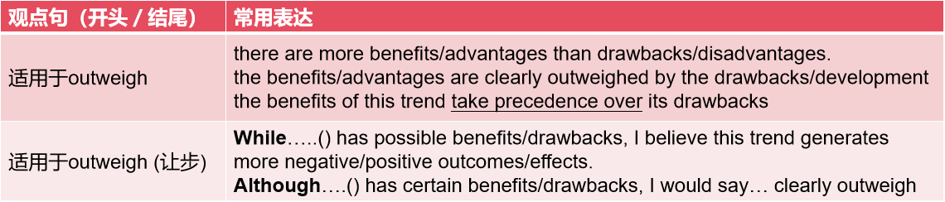

Agree or disagree
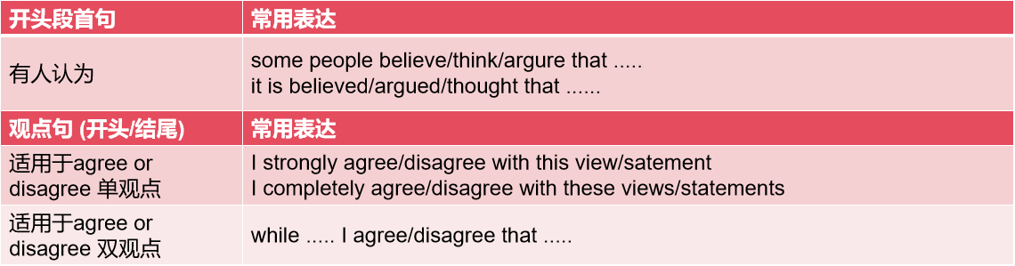

Discussion

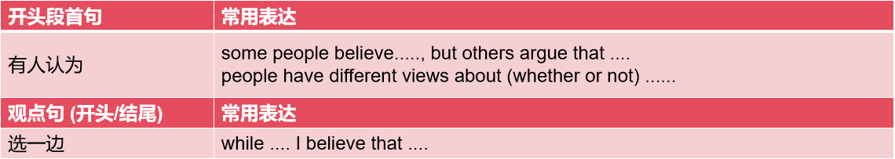

结尾段写作句型
结尾段格式：重申观点 + 总结主体段内容 (论点)
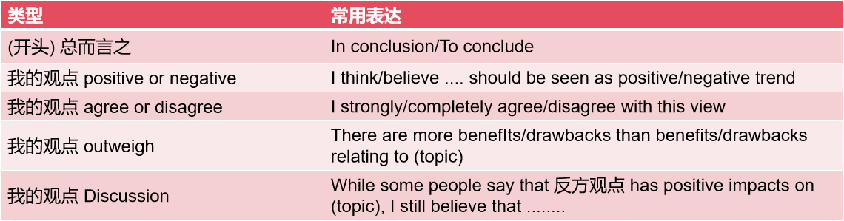
- In conclusion, I believe that ...., as/since/because (因为) .....
Nowadays more tasks at home and work are being performed by robots. Is this a positive or negative development?
In conclusion, I believe that robots implement tasks in domestic and working context should be seen as a positive trend, as it improves people’s quality of life and boots productivity at work, as well as preventing workers from dangers

单观点
It is a natural process for animal species to become extinct (e.g. dinosaurs, dodos, etc.). There is no reason why people should try to prevent this from happening. To what extent do you agree or disagree?
.In conclusion, I completely disagree with this view, as protecting animals can help preserving biodiversity and secure the benefits that they provide

双观点部分同意
Nowadays, a large amount of advertising is aimed at children. Some people think this can have negative effects on children and should be banned. Do you agree or disagree?
In conclusion, while I agree that advertising directed to children can be harmful, I do not think/disagree that government should impose a ban on them. This is because this advertising could negatively affect children’s value and eating habits, but the ban on them can decelerate the economic growth 使经济发展迟缓 and deprive the right 剥夺权力of the manufacturers.
- In conclusion, 重申观点, as it not only but also ...
In some countries, the widespread use of the internet has given people more freedom to work or study at home, instead of travelling to and from work or college. Do advantages of this development outweigh disadvantages?
In conclusion, there are more benefits than drawbacks relating to remote working or learning, as they not only make the life become more flexible and are environment-friendly, but also the drawbacks can be tackled by setting deadline and creating quiet area.

Some people say that children should go to school as young as possible, while others believe that children should not start primary school until they are six or seven-years-old. Discuss both views and give your own opinion.
In conclusion, although children could improve their development in a certain learning environment, I do not think children should go to school at very early age because of less pressure way of skill development by socializing with friends and poor learning efficiency.

- 中立思路 - Discuss both views and give your opinion: 4段式
Personally, I believe that both A and B can be used to ....
Personally, I think that .......(短语) and ......(短语) can be good options to .....

全文篇章写作
Some people say the government should put money in the art, such as music, opera and
paintings, but others think more money should be spent on the construction of infrastructure. Discuss both views and give your own opinion.

People have different views about which sector should be prioritized in terms of investment. In my opinion, this should depends on the situation each country experience.

This is because it can boost local economy. The art projects in the local can appeals tourists to visit there, which generates a large amount of consumption. For example, Paris, which is famous for art collections, is visited by a great number of tourists around the world. These tourists consume the housing, eating and shopping. All of this revenue can accelerate the local economy.

They think that artistic and cultural projects surely bring many advantages to the whole society. Apparently, the projects can help people to cultivate a better taste for arts and enhance their sensitivity to beauty, thus enriching their spiritual life and upgrading their quality of life. Furthermore, these artistic projects are certainly not a money waster. Instead, they are potentially profitable as a beautiful city tends to draw more tourists, thereby boosting local economy. And the money earned can be further applied for the improvement of local standards of living, as well as for the construction of basic infrastructure.

However, others hold that priority should be given to infrastructure. Nowadays, many countries are still struggling to achieve modernization and many people are still living below the poverty line. It goes without saying that it is difficult to enjoy cultural and leisure pursuits if one’s transportation, sanitation and living environment are inadequate. So, surely no one would disagree that it is unreasonable to spend government revenue on cultural projects while millions of people still do not enjoy proper condition of sanitation, transportation, public areas and facilities, gas, water and electricity, access to high speed internet etc.

Personally, I agree that more public money should be spent on artistic and cultural projects in much developed countries, as they contribute substantially to the landscaping of cities and are able to repay infrastructure, whereas in less developed economies, infrastructural facilities should be attached greater importance.

The best way for a government to solve the problem of traffic congestion is to provide free public transport 24 hours a day, 7 days a week. To what extent do you agree or disagree?

作业
Some people believe that they should be able to keep all the money they earn and should not pay any tax to the state. To what extent do you agree or disagree?

